KWA 100/100SE Power Amplifier

Owner’s Manual

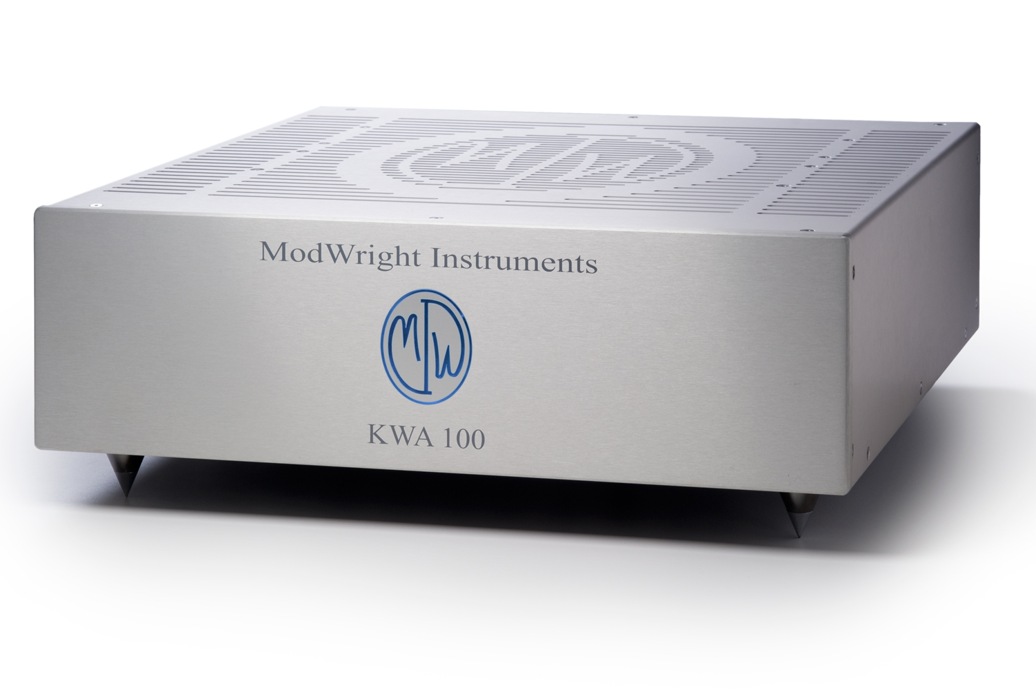

Manufactured by ModWright Instruments, Inc.
21919 399th St., Amboy, WA 98601
USA
www.modwright.com
PLEASE READ FIRST:

General guidelines explain operation and protection circuitry of the amplifier.

- Startup:
  - To power the unit up, turn the rocker switch on the back to the up position. This turns power on to the unit, but it remains in standby until the front 'active' switch is depressed. This switch is located under the front left corner of the unit, adjacent to the left front spike footer. When you do this, the unit will turn on and logo/button and internal blue lights will flash for approximately 45 seconds. This is normal and is part of the startup and stabilization process.

  - If the unit does not power up at this point, check to be sure that power plug is firmly seated and that you are connected to the proper mains voltage. I.E. US/Canada 120V, HK 220V, Europe and other countries 220V-240V.

- Protection Circuitry:
  - This unit has multiple levels of circuit protection, intended to protect the amplifier and speaker from potential damage.

  - DC input protection is served by transformer input coupling.

  - Thermal overload protection is served by internal thermal overload protectors. Upon thermal overload, the unit will simply shut down. There will be no red lights, the unit will simply power down as the overload circuit cuts all power to unit.

  - Short-circuit and over-current protection is served by our unique and proprietary TSP_{TM} Total Silent Protection circuitry which resides outside of the signal path. When protection is triggered, channel or channels effected simply mute. To reset, turn rear power rocker switch off, wait ten seconds and power back up. DO NOT plug and unplug RCA signal connectors when amp is on, or turn amp on without RCA or XLR signal connectors in place. If you do plug or unplug signal connectors (RCA or XLR) while amp is on, protection circuitry may engage. This will be apparent by the fact that one or both channels are muted. If so, turn amp off, let sit for 10 seconds and power back on again.

- Fuses:
  - All fuses are internal and are only to be replaced at the factory or by factory authorized technician. There are no user serviceable parts inside and opening unit will void the factory warranty.
General Operation:

Note: It is always recommended that you power the amplifier on last, when powering up your audio system. When powering your audio system down, it is always recommended to power the amplifier off first.

Powering On:

- When first turned on, the button/logo and insides of the unit will flash on/off in blue for approximately 45 seconds. It is during this time that the amp is warming up and stabilizing. After this, lights will stay blue and the amp will be on.

- It is always recommended that you power the amplifier on last, when powering up your audio system. When powering your audio system down, it is always recommended to power the amplifier off first.

Stereo operation:

- The KWA 100 is designed to provide over 100W into an 8 ohm speaker load and 200W into a 4 ohm speaker load. It has been tested into 2 ohm loads and found to perform well. If the speaker load represents TOO low of an impedance, the amp will simply protect itself by muting due to its over-current protection circuitry.

LED ON/LED OFF Switch:

- You will find on the back of the amplifier, a switch labeled LED ON/ LED OFF. This switch turns on/off the internal blue LEDs. This may be done at any time and has no impact on sound of the amplifier.

Ground Switch:

- Adjacent to the power connector is a toggle switch labeled ‘Gnd’. It allows the user to change the internal grounding characteristics of the amp to prevent system specific ground loops. The signal inputs are transformer-coupled and as such, do not allow for grounding issues. Every system is different however, and if a grounding issue is present, moving the ground toggle from one state to the other, may aid in resolving power grounding issues. The chassis is ALWAYS grounded to EARTH ground, but with the Ground toggle in the UP position, signal ground is not tied to the chassis and earth ground. In most cases, the ground switch should remain in the ‘down’ position. A grounded AC power cord should ALWAYS be used with this product.

Connections:

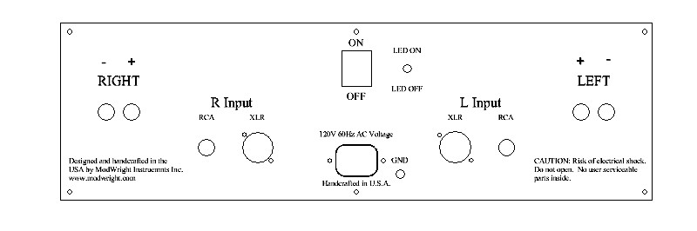

- Inputs: One pair RCA; One pair XLR. RCA and XLR inputs are transformer coupled to input stage with floated ground. Connect to preamp outputs.
- Outputs: Left and Right 5-way binding posts. Connect to speaker binding posts.
- Led On/ Led Off Switch: Turns internal LED’s On/Off.
- Main Power Toggle: Turns mains power to unit On/Off.
- GND Toggle: Allows for connection of signal ground to chassis ground.
- Mains power inlet. Connect to power mains of appropriate voltage. If labeled 120V, plug into 120VAC mains outlet. If labeled 220V or 240V, then plug into appropriate AC mains outlet. ALWAYS USED GROUND AC POWER CORD.
Specifications:

Power Ratings:

- 100W @ 8 ohms (Stereo) @ .06% THD.
- 200W @ 4 ohms (Stereo) @ .06% THD.

Technical Specifications:

- Bandwidth: 10Hz - 100Khz (+0, -1dB)
- Noise Floor: -95dB
- Channel Separation: -70dB below 20Khz
- Gain: 26dB
- Input Impedance: Min. 15K at 50Hz; 23K at 1Khz

Weight and Dimensions:

- Dimensions: 17"W x 17"D x 5.5"H
- Shipped Weight: 47lb
KWA 100SE Upgrades:

- Upgraded signal path capacitors – MWI Custom Oil-impregnated poly types.
- Upgraded signal path resistors – Takman Carbon Film.
- Total output power supply capacitance increased 100%
- Total number of output devices (MOSFET Pairs) increased from 3 pairs to 5 pairs.
- Sonic differences between KWA 100 and KWA 100SE:
  - Greater overall current available to output stage, translating to increased speed, bass response, resolution and micro-detail/dynamics.
Warranty:

ModWright agrees to warranty product for a period of 5 years from date of purchase from a factory authorized ModWright Instruments Dealer.

Warranty covers parts and labor for repairs due to equipment failure not related to customer abuse and/or neglect. Customer is responsible for shipping costs to and from ModWright Instruments or authorized service center.

There are no user-serviceable parts inside the amplifier and evidence that someone other than a ModWright Instruments Factory Authorized service professional has opened the product enclosure or in any way tampered with the internal workings of the unit, including replacement of stock fuses, will void factory warranty.

Warranty is non-transferable to second party.

Contact Information:

If you have any questions about ModWright Instruments products or ModWright modifications or products, please do not hesitate to contact us via phone, e-mail or conventional mail.

PH: 360-247-6688

EMAIL: modwright@yahoo.com

ADDRESS:

ModWright Instruments, Inc.
21919 NE 399th St.
Amboy, WA 98601
United States of America

Thank you for purchasing a ModWright Instruments product.

Dan Wright,
President, Owner
ModWright Instruments, Inc.

