KWA 150/150SE Power Amplifier

Owner’s Manual

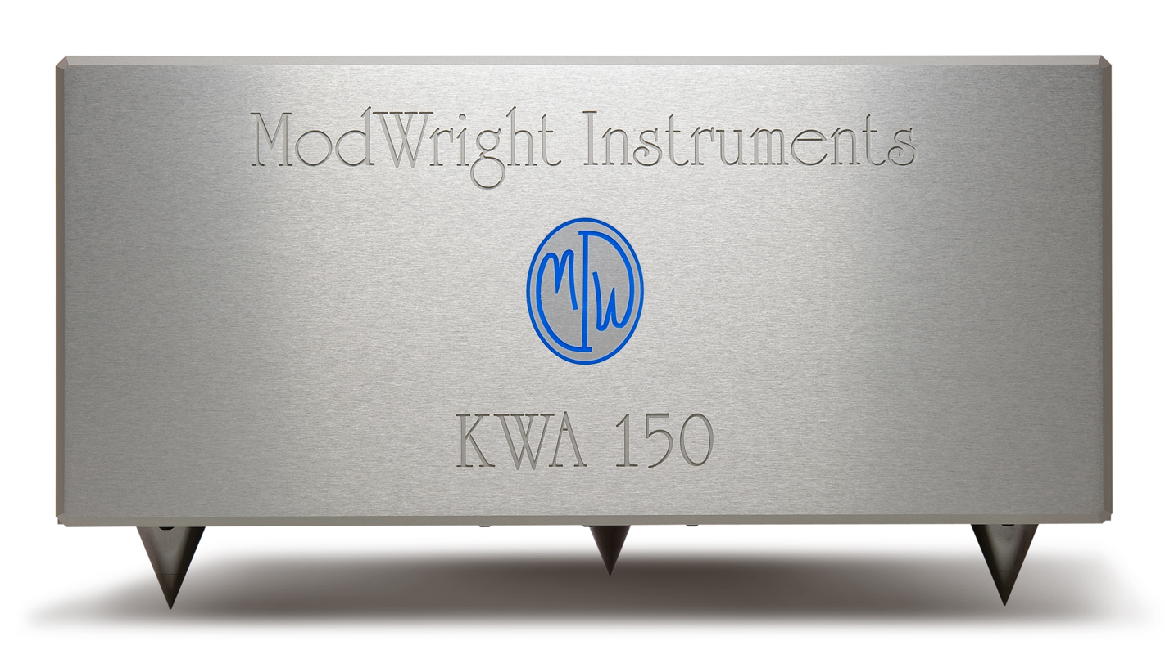

Manufactured by ModWright Instruments, Inc.
21919 399th St., Amboy, WA 98601
USA
www.modwright.com
PLEASE READ FIRST:

General operation and protection circuitry of amplifier.

- Startup:
  - To power unit up, simply depress the large MWI logo on the faceplate of the amp. When you do this, the unit will turn on and logo/button and internal blue lights will flash for approximately 45 seconds, while amp output is muted. This is normal and is part of the startup and stabilization sequence.

  - If unit does not power up at this point, check to be sure that power plug is firmly seated and power cord is connected to mains voltage indicated on back panel of amplifier. US/Canada 120V, HK 220V, Europe and other countries 220V-240V.

- Protection Circuitry:
  - This amplifier has multiple levels of circuit protection, to prevent damage amplifier and speakers.

  - DC input protection is provided by transformer input coupling.

  - Thermal overload protection is provided by internal thermal sensors. Upon thermal overload, amp will simply shut down. There will be no red lights, the unit will power down as the overload circuit cuts all power to unit. If this happens, let amp cool and then turn back on.

  - Short-circuit and over-current protection is provided by our unique and proprietary TSP_{TM} Total Silent Protection circuitry, which resides entirely outside of the signal path. When protection is triggered, the channel or channels effected simply mute, or the amp shuts down. To reset, simply power the unit off, wait ten seconds and power back up.

  - DO NOT plug and unplug RCA signal connectors when the amp is on, or turn the amp on without RCA or XLR signal connectors in place. If you do plug or unplug the signal connectors (RCA or XLR) while the amp is on, you may engage protection circuitry, as will be apparent by the fact that one or both channels are muted. If so, turn off amp, let it sit for 10 seconds and power it back on again.

- Fuses:
  - All fuses are internal and are only to be replaced at the factory or by factory authorized technician. There are no user serviceable parts inside and opening the unit will void the factory warranty. If unit protection triggers and amp will not re-start, please contact factory.
General Operation:

Note: It is always recommended that you power the amplifier on last, when powering up your audio system. When powering your audio system down, it is always recommended to power the amplifier off first.

- Stereo operation:

  - Connect Left and Right XLR or RCA cables from preamp to Left and Right inputs on back panel of amp.

  - Connect (+) and (-) Left and (+) and (-) Right speaker cables from binding posts on back of amplifier to speakers.

- Mono operation:

  - The KWA 150 may also be operated as a mono amplifier, in bridged configuration. The Mono binding posts are internally wired for bridged operation. To operate in bridged mono mode, plug preamp into the Left input (MONO), speaker cables to Mono binding posts and toggle Mono switch to the up position.

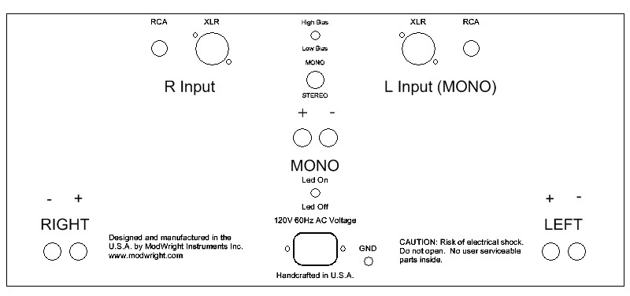

Caution: Do not connect the Mono binding post to any speaker circuitry that grounds any speaker lead. If either terminal of the Mono binding post are connected to GROUND when operating in bridge-mono mode, damage to the amp may occur.
It is not recommended to run the amplifier in bridged mono into 2ohm loads.

- High/Low Bias Operation:

  - High/low bias toggle is located on the rear of the amp, above the MONO binding posts. The bias status indicates how much current the amplifier output devices receive at idle. The best sonics are typically achieved in high-bias. This bias level also generates the highest amount of radiated heat and draws the most mains current. The unit may operate in either high or low bias state. Bias may be switched from High to Low bias during operation.

- Ground Switch:

  - Adjacent to the power connector is a toggle switch labeled ‘Gnd’. It allows the user to change the internal grounding characteristics of the amp to prevent system specific ground loops. The signal inputs are transformer-coupled and as such, do not allow for grounding issues. Every system is different however, and if a grounding issue is present, moving the ground toggle from one state to the other, may aid in resolving power grounding issues. The chassis is ALWAYS grounded to EARTH ground, but with the Ground toggle in the UP position, signal ground is not tied to the chassis and earth ground. In most cases, the ground switch should remain in the ‘down’ position. A grounded AC power cord should ALWAYS be used with this product.

Specifications:

Power Ratings:

- 150W @ 8 ohms (Stereo) @ .06% THD.
- 450W @ 8 ohms (Bridged Mono) @ .06% THD.
- 200W @ 4 ohms (Stereo) @ .06% THD.
- 650W @ 8 ohms (Bridged Mono) @ .06% THD.

Technical Specification:
- Bandwidth: 10Hz - 100Khz (+0, -1dB)
- Noise Floor: -100dB
- Channel Separation: -75dB below 20Khz
- Gain: 26dB
- Input Impedance: Min. 15K at 50Hz; 23K at 1Khz

Weight and Dimensions:

- Dimensions: 17"W x 17"D x 8.5"H
- Shipped Weight: 84lb
KWA 150SE Upgrades:

- Upgraded input stage circuitry, resulting in lower distortion and noise levels.

- Higher Quality Lundahl input transformer with larger signal capacity.

- All ultra-pure copper, solid-core, cryo-treated audio-grade input signal wiring.

- Output wiring upgraded to 12GA Cardsas Litz wire.

- Redesigned output stage power supply design, provides both 25% more capacitance and significantly lower power supply impedance.

- Increased output current capacity and speed.

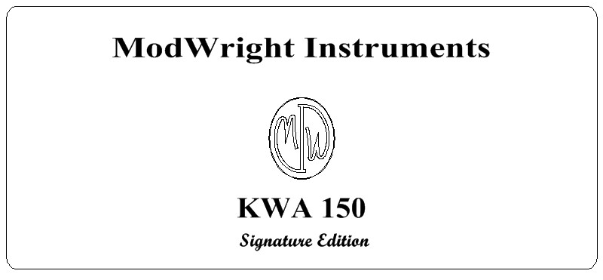

WARRANTY:

ModWright agrees to warranty product for a period of 5 years from date of purchase from a factory authorized ModWright Instruments Dealer.

Warranty covers parts and labor for repairs due to equipment failure not related to customer abuse and/or neglect. Customer is responsible for shipping costs to and from ModWright Instruments or authorized service center.

There are no user-serviceable parts inside the amplifier and evidence that someone other than a ModWright Instruments Factory Authorized service professional has opened the product enclosure or in any way tampered with the internal workings of the unit, including replacement of stock fuses, will void factory warranty.

Warranty is non-transferable to second party.

Contact Information:

If you have any questions about ModWright Instruments products or ModWright modifications or products, please do not hesitate to contact us via phone, e-mail or conventional mail.

PH: 360-247-6688

EMAIL: modwright@yahoo.com

ADDRESS:

ModWright Instruments, Inc.
21919 NE 399th St.
Amboy, WA 98601
United States of America

Thank you for purchasing a ModWright Instruments product.

Dan Wright,
President, Owner
ModWright Instruments, Inc.

