ModWright Instruments Inc.

KWI 200 Integrated Power Amplifier

Owner’s Manual

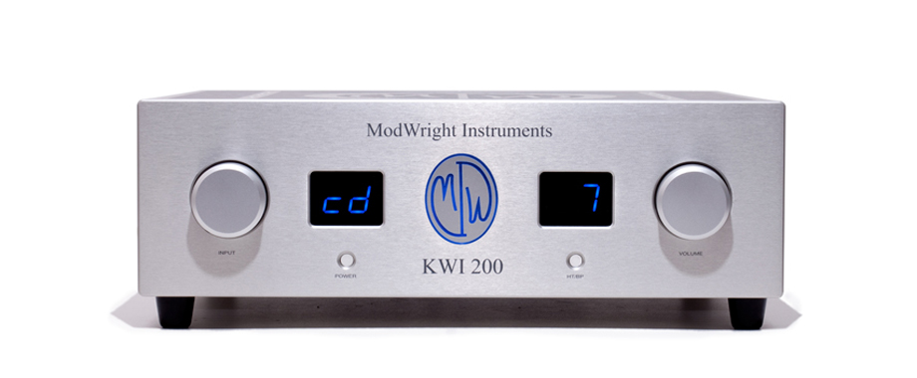

Manufactured by ModWright Instruments, Inc.
21919 399th St., Amboy, WA 98601
USA
www.modwright.com

ModWright Instruments, Inc.
21919 399th St., Amboy, WA 98601
Proudly Handcrafted in the USA
www.modwright.com

PLEASE READ FIRST (SAFETY):

Water and moisture: Electrical devices should not be used near water, such as near a bathtub, sink, laundry tub, wet basement or swimming pool. Care should be taken such that objects do not have the opportunity to fall, and that liquid is never spilled onto or into the device enclosure through openings.

Power Sources: This electrical device must be connected to a mains power source in strict accordance with the supplied product owner’s manual. Please verify that the AC mains voltage specified in the product manual match those requirements indicated on the unit and the AC voltage provided to your location by the power company. Unplug this apparatus during lightening storms or when unused for long periods of time. To completely disconnect this apparatus from mains power, disconnect the power cord from the AC receptacle. The equipment power switch does not provide adequate protection to be considered a service disconnect.

Grounding: Adequate precautions should be taken so that the grounding provisions built into an electrical product are never defeated. Product should ONLY be plugged into a properly grounded wall outlet.

Ventilation: Power-amplifiers run warm, but you should be able to place your hands on them without discomfort. You must allow adequate ventilation in installation, by providing for free air circulation around the product. Electronics should not be subjected to sources of excessive radiant heat. Excessive heat can shorten the life of the product and may cause the electronics to self protect and shut down. Never block any ventilation openings. Allow at least 2 inches of clearance around these products for proper ventilation.

Servicing: To reduce the risk of fire, electrical shock or other injuries, the user should not attempt to service the device beyond that which is described in the operating instructions. All other servicing must be referred to qualified service personnel. There are no user serviceable parts inside.

Protection Circuitry:

- Protection Circuitry:
This amplifier has multiple levels of circuit protection, designed to prevent damage to amplifiers, speakers and connected equipment.

  - DC input protection provided by transformer input coupling.

  - Thermal overload protection provided by internal thermal sensors. Upon thermal overload, amp will simply shut down. The message “00” “P5” (“OOPS”) will be visible on displays and will go out after 8 seconds. If this happens, let amp cool and then turn back on.

  - DC Output Protection provided by our unique and proprietary TSP_{TM} “Total Silent Protection” circuitry, residing entirely outside the signal path. When protection is triggered, the amp shuts down and the message “00” “P5” (“OOPS”) will be visible on displays. Message will remain for approximately 8 seconds. If amp continues to encounter this fault condition, and will not turn on, contact dealer or ModWright service agent.

- Fuses:
  - All fuses are internal and are only to be replaced at the factory or by factory authorized technician. There are no user serviceable parts inside and opening the unit will void the factory warranty. If unit protection triggers and amp will not re-start, please contact factory or ModWright service agent.
Setup and General Operation:

- Setup:

  - Amp may be installed anywhere BUT in enclosed closet or cabinets with no means for adequate air circulation. It is also not recommended to stack any components directly on top of amp or to stack amp directly on top of any other components. Never block ventilation in top of amplifier as this will prevent cooling and can lead to damage of amplifier.

  - Because amplifier operates in Class A/B, there is not a huge current draw at idle. As such, you may leave the amp on when not in use and it will not draw more than a few watts. It is recommended to disconnect amp power cord from wall if unit will not be used for extended periods.

  - Amplifier is equipped for operation with an earth ground provided by the user’s AC outlet. It is recommended to only plug amp into AC outlets that are earth-grounded. Signal ground and chassis ground are both common to earth ground. This ground connection should never be defeated or altered. It is grounded for your safety.

- Startup:
  - First check to be sure that power plug is firmly seated and power cord is connected to mains voltage as indicated on back panel of amplifier. US/Canada 120V, HK 220V, Europe and other countries 230V-240V.
  - To power unit up, simply depress the power button on the faceplate, or the power button on the remote control. When you do this, the unit will turn on and MWI logo will illuminate blue. Right hand digital display (volume) will indicate via alternating pattern, that unit is warming up and stabilizing. This will take approximately 45 seconds, while amp output is muted. This is normal and is part of the startup and stabilization sequence.

  - If unit does not power up at this point, or shuts down in the process and the displays read: “00” and “P5” (or “OOPS”) then there is a fault and the amp has shut down on protection. Unplug amp, wait 30 seconds, plug back in, and initiate startup sequence. If protection mod re-occurs, call your dealer or ModWright service agent.

Rear Panel and Connections:

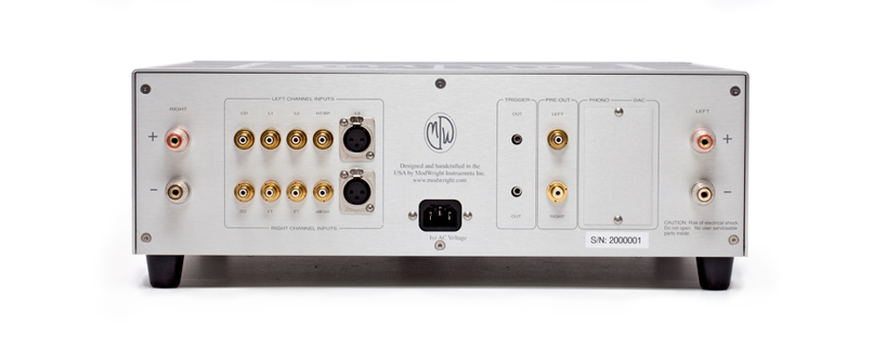
- Power entry module – center.
- Binding posts – Right and Left, marked ‘+’ and ‘-‘.
- Three sets of RCA inputs, labeled ‘CD’, ‘L1’, ‘L2’.
- One set of XLR inputs, labeled ‘L3’.
- One set of RCA HT/BP – Home Theater Bypass (Also function as Preamp Inputs).
- Two 12V trigger outputs – remote controlled.
- One set of RCA preamp outputs. Input source selected is always present at RCA preamp outputs and may be used to drive a second or different amplifier.
- Cover plate may be removed when optional Phono and USB DAC options are installed.

Front Control and Displays:
- Left control knob rotates freely. Turning knob in clock-wise direction will toggle through available inputs
- Left button is power. Depressing button will power unit on or off. Unit may also be powered on or off via remote control power button.
- Right button is HT/BP (Home Theater Bypass – Also acts as preamp input). When this button is pressed, input display will read ‘bp’ for ‘bypass’ and volume display will read ‘--‘ This will bypass the preamp section of the Integrated Amp and feed whatever source is connected to HT/BP RCA inputs, straight to the amplifier, with NO attenuation or volume control. It is recommended that the HT/BP input ONLY be connected to a separate preamp or a preamp/processor for Home Theater use.
- Right control knob rotates freely. Turning knob in clock-wise rotation will increase volume from mute = ‘- -‘, numerically from 01 – 99. Remote control may also be used to adjust volume. Volume level is only displayed on digital display.
- Left digital display will indicate inputs as: CD, L1, L2, L3, (P1, P2 if phono option installed), (D1, D2 if DAC option installed) and ‘bp’ when HT/BP button is depressed. In fault mode, left digitital display will read ‘00’ and right display will read ‘P5’.
- Right digital display indicates volume level
- MWI logo in center will be lit blue when unit is turn on and in operation. If displays are dimmed or turned off, logo will remain lit. It may not be turned off.
- Digital displays may be dimmed from bright to off, by depressing the ‘*’ button on the remote. Each time button is depressed, displays dim to lower level until they are turned off. When displays are turned off, they will light up for approximately 7 seconds whenever any controls are adjusted or remote functions activated.
Remote Control Functions:

Please note that the ModWright remote is used by a number of different products in our family and not all functions on remote will be used by this product.
- Power: Turns unit on and off.
- ‘*’: Serves to dim display luminance or turn display ‘off’.
- Input: Toggles through available inputs.
- Phase: Not used.
- Mon.: Not used.
- Bal.: Not used.
- Mute: Mutes signal.
- Trig.: Activates two 12V DC trigger outputs.
- Volume ‘-‘: Turns volume down in level.
- Volume ‘+’: Turns volume up in level.

Specifications:

Power Ratings:

- 200W @ 8 ohms @ .06% THD.
- 400W @ 8 ohms @ .06% THD.

Features:
- (3) pairs RCA inputs.
- (1) pair XLR inputs.
- (1) pair RCA Home Theater Bypass or Preamp Input.
- (1) pair RCA Preamp-ouputs.
- (2) 12V Trigger outs.
- (2) Pairs 5-way binding posts.
- Remote Control: Volume, Mute, Input, Power, Trigger, Display dim/off.
- Optional: DAC with USB (24/192 Asynchronous) and RCA inputs.
- Optional: MM/MC Phono with one pair RCA inputs.

Technical Specification:
- Bandwidth: 10Hz - 100Khz (+0, -1dB)
- Gain: 34dB
- Input Impedance: 20K
- Input Sensitivity: 1V
- Max input level: 6 Vrms (18V pk-pk)

Weight and Dimensions:

- Dimensions: 17"W x 17"D x 6"H
- Shipped Weight: 62lb

WARRANTY:

Please check with factory-authorized distributor, in the country that you are purchasing this product, for specific warranty information.

All ModWright products purchased from an authorized ModWright Instruments dealer, in North America, are covered by a non-transferrable, limited 5-year warranty. This warranty includes all parts and labor charges incurred at repair facility, but not shipping. Damage due to physical abuse is specifically not covered under this warranty.

For this warranty to apply, the customer is responsible for returning the product unmodified to the factory within the warranty period. The customer assumes all responsibility for shipping and insurance to the factory or a factory specified repair facility. The conditions and stipulations of this ModWright Instruments warranty only apply to units sold new in North America.

Please note: Conditions of warranty service and customer rights, for product purchased outside the United States, may vary depending upon the distributor and local laws. Please check with your local distributor for specific rights and details.

Any modifications to ModWright Instruments products, that have not received written factory approval, nullify all claims and void the warrantee. This includes aftermarket fuses that are not installed in unit from the factory. Should a modified product be returned to the factory for repair, the owner will be required to pay all necessary charges for the repair in addition to those charges required to return the product to its original configuration.

In the case of safety issues, no product shall be returned to the customer without those safety issues being corrected to the most recent accepted standards.

Removal or alteration of original ModWright Instruments serial numbers voids the factory warranty. Product with altered or missing serial numbers will be suspected as counterfeit product.

ModWright Instruments will not repair or in any way indemnify any counterfeit or cloned product.

ModWright Instruments does not offer products in voltages intended for international markets, either to authorize ModWright Instruments dealers or to third parties, located in the United States or Canada.

Warranty is non-transferable to second party.

Contact Information:

If you have any questions about ModWright Instruments products or ModWright modifications or products, please do not hesitate to contact us via phone, e-mail or conventional mail.

PH: 360-247-6688

EMAIL: modwright@yahoo.com

ADDRESS:

ModWright Instruments, Inc.
21919 NE 399th St.
Amboy, WA 98601
United States of America

Thank you for purchasing a ModWright Instruments product.

Dan Wright,
President, Owner
ModWright Instruments, Inc.

