Oppo BDP-105 Tube Modification

ModWright Instruments, Inc.

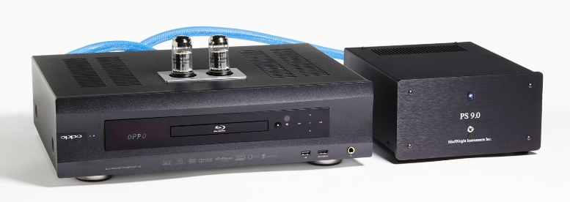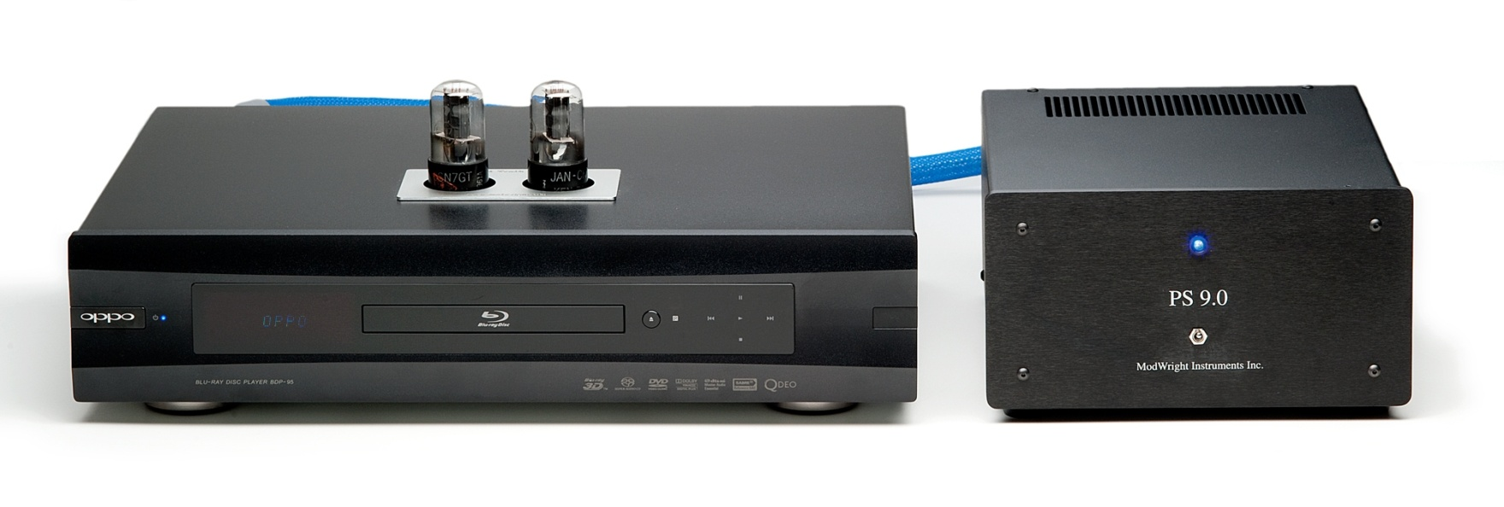

 

**TUBE MODIFICATION - $2495 USD**

**Our most dynamic and musical modification for the Oppo BDP-105 Universal Player & DAC!**

**REFERENCE UMBILICAL**

**Cryo-treated materials, made from equal parts 99.9999% solid-core silver and copper, for the two high-voltage leads. The main ground is 18GA Cardas litz with proprietary geometric orientation.**

**(Included in the price of the tube modification)**

**BYBEE RAIL UPGRAGDE - $225 USD**

**Improves resolution, detail and decay which leads to a broader sound stage and more natural presentation, without edge or glare.**

**REGION FREE UPGRADE - $250 USD**

**This will allow a player purchased in the U.S. to play all regions of DVD, DVD-A, SACD and**

**Blu-Ray discs.**

**MODIFICATION OPTIONS**

**- Enclosure and drive vibration damping for lower jitter and less digital glare.**

**- 5AR4 tube rectifier , 13EM7 voltage regulator and 6SN7 driver tubes allow for broad range of tube rolling, to obtain the right tonal balance for your system.**

**SONIC BENEFITS?**

**Our modification provides a fuller, richer midrange and even more extended highs and expanded soundstage. Bass is extremely deep and well defined. The overall presentation combines midrange warmth, broad bandwidth, sparkling detail and resolution, WITHOUT the common aggressive edge and glare found in lesser digital components!**

**Dan Wright, CEO**



**WHATS INCLUDED?**

**- Removal of all feedback-based op-amp analog circuit.**

**- Direct coupling of DAC output to ModWright's I-V circuit.**

**- Direct coupling of I-V circuit to ModWright's fully balanced 6SN7 based Class “A” tube stage**

**- 99.9999% CARDAS Pure Solid Core Silver Signal Wiring throughout the mod.**

**- Top quality parts throughout, including MWI capacitors and Takman Japanese carbon film resistors.**

**- External tube-rectified and tube regulated high-voltage tube supply powers ModWright tube analog stage.**

**- 'Truth' umbilical provides clean and pure DC power for improved detail, dynamics and soundstage.**

**- FURUTECH IEC Upgrade**

**OPPO BDP-105 TUBE MODIFICATION**

**21919 NE 399th Street, Amboy, WA 98601 Tel 360.247.6688 modwright@yahoo.com www.modwright.com**